BOOKING GUIDELINE for FLEXITANK (FLEXIBAG) PACKAGED CARGOES 液袋包装货物订舱指南

For FLEXITANK/FLEXIBAG shipments, please kindly follow up the booking procedure as below:
对于液袋包装货物，请遵循如下订舱流程：

- Booking Agent send EDI Booking to MSC, declaring package type as “Flexibag”.
订舱代理发送EDI电子订舱至我司，选择包装类型为 “Flexibag”。

- Booking Agent submit Flexitank Application to below email address with all required documents attached:
订舱代理将所需的申请资料及信息以邮件形式发送至以下地址：

邮件主题:
Flexitank Application – Vessel/Voyage – Service Name – Booking Number

邮件发送地址: CHN-CSEXP.BKGFOC@MSC.COM

邮件正文中所需提交的申请资料及信息:
- Booking Number:
- Vessel/Voyage:
- POL/POD:
- FLEXITANK LOI (外代网站可下载)
- MSDS和运输条件鉴定书(以附件形式发送，请确保该货物的闪点Flashpoint数值已准确无误的录入到MSDS中):
- Flexitank Type:（请从以下链接中挑选正确的液袋类型并填写）
液袋类型参考网站https://www.containerownersassociation.com/coa-fqml/

- Please confirm by return in flexitank shipment application email body that compatibility check is performed and passed with success, and could meet the safety requirements.
请在液袋申请邮件正文中，以书面形式确认给我司对于所出运的液袋货物已经通过以下一系列的测试要求：

We confirm the Flexitank materials of construction shall be entirely resistant, inert and free from any risk of degradation or reaction to the cargo at the filling and transport temperature. Flexitank material resistance and temperature compatibility charts and test procedures are required to be included in the manufacturer’s operating instruction and training manual. A compatibility risk evaluation shall form part of the required risk assessment required to be undertaken by the responsible persons.

我司确认该票集装箱液袋的材质应完全耐受、惰性，且在装填和运输温度下不会发生任何降解或与货物发生反应的风险。制造商的操作说明和培训手册中必须包含集装箱液袋材质的耐受性和温度兼容性图表以及测试程序。兼容性风险评估应作为责任人员必须进行的风险评估的一部分。
- MSC screen all the documents and information, and submit the application to Antwerp DC Center for final approval, and then confirm the booking.
MSC审核申请资料和信息，并提交液袋申请至安特卫普危险品中心，在得到其批复后确认订舱。

- Pls take note FlexiTank (bag) label is mandatory and response by shipper.
装箱完毕后，客户务必提供并且在柜子上张贴FlexiTank (bag)标签, 如有由于FlexiTank (bag)标签丢失或不符合要求所产生费用/责任/风险，由客户自行承担。
FlexiTank (bag) label 样本:
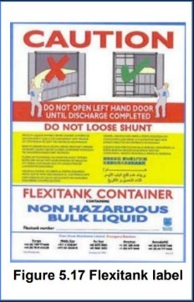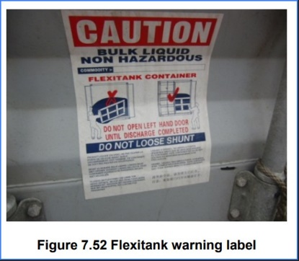
Attention point /标签注意事项:
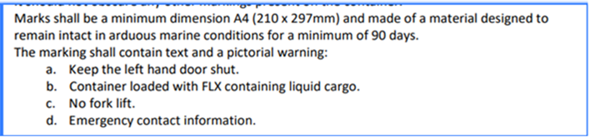

液袋货物装柜注意事项:
- Dangerous cargo is not allowed in FlexiTank (bag).
危险品货物不得装载在液装包装中。

- The max weight exceeds 24,000KGS or 24,000 L is not allowed for each container.
每个液袋货物柜子的货重不得超过24,000 KGS 或者24,000 升(任一条件都不能超过)。

